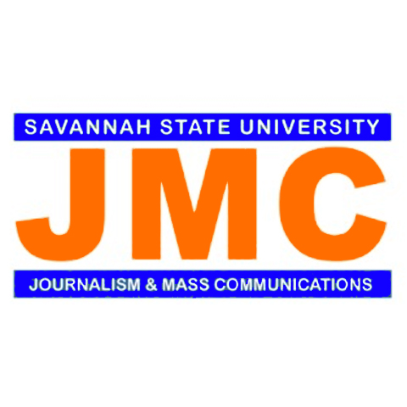
Mentee’s Application for the Department of Journalism and Mass Communications
Alumni Mentoring Program
Application for Student Seeking a Professional Mentor

(Students: The information you provide on this form will be shared with the department chair, the mentor coordinator, and the person who will become your professional mentor)

Name: Last__________________________First:_____________________Maiden:________________

Email Address:___________________________Hometown:_________________________________

Phone Number: ______________________________

Concentration (check one): ______Audio/Video _____P.R. and Advertising ____Online Journalism

Expected Date of Graduation: __________________

Demographics: Age:______ Male:______ Female:______

What professional field or experiences would you like for your mentor to know about you?
____________________________________________________________________________________
____________________________________________________________________________________
Why do you want a mentor (check all that apply)?
_____Career Guidance
_____Help me improve my social and professional skills
_____Assist me in improving skills areas in which I need help
_____Mentor me in joining a JMC student organization/student media

To better match you with a professional mentor, please provide us with information about your career goals and aspirations. Please be specific.
___________________________________________________________________________________
___________________________________________________________________________________
___________________________________________________________________________________
Have you completed a professional media internship? If so, with what organization, what were your job responsibilities and what skills did you acquire?
_____________________________________________________________________________________
__________________________________________________________________________________________________________________________________________________________________________
Return this completed form by email to holmesn@savannahstate.edu or print and deliver to the JMC Office

