Accommodations

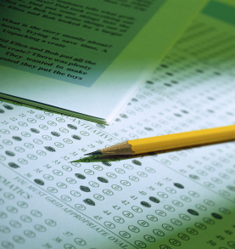
All students need to realize that the intake process, documentation review and arrangements for accommodations take time. Please apply for services well in advance. It is best to call and schedule an intake appointment with Ms. Amelia Castilian-Moore as soon as you are accepted for admission to Savannah State University or told that you need to take a Compass Test for Admission.
Services offered, based on the individual student's needs, may include: registration assistance, consultation with faculty, registration assistance, referrals to resources, reader services for tests, enlargement of print materials, scribe services for tests, extended time on tests, low distraction test room, permission to tape lectures, adaptive software, electronic read aloud books.
All students who have been approved for accommodations receive an Accommodation Letter each semester to show to their professors. The Accommodation Letter outlines the student's approved accommodations. It is the student's responsibility to pick up this letter each semester, discuss their needs and accommodations with their professors, and have their professors sign the acknowledgement form. The student is responsible for returning the signed acknowledgement form to the Office of Counseling and Disability Services each semester.
Services are available to those students who choose to self-identify and provide appropriate documentation of their disability. SSU does not offer separate classes for students with disabilities. Through the assistance of the Office of Counseling and Disability Services and other support services on campus, SSU strives to provide a quality educational experience for all qualified students with disabilities. All services of the Office of Counseling and Disability Services are provided at no charge.

