Table of Contents

WELCOME 3
IMPORTANT PHONE NUMBERS 4
CORTRAMID EAST STAFF 5
USN STAFF AT KINGS BAY, ga…………………………………………………………………… 6
USMC CORTRAMID STAFF AT CAMP LEJEUNE, NC 6
FLEET LIAISON OFFICERS 6
MIDSHIPMEN ORGANIZATION 7
DUTIES AND RESPONSIBILITIES OF MIDSHIPMEN 7
BERTHING 8
MESSING 8
IDENTIFICATION CARDS 9
UNIFORMS 9
CIVILIAN ATTIRE 9
CORTRAMID STAFF DUTY OFFICER 10
PLAN OF THE DAY 10
OPERATIONAL CONSIDERATIONS 10
TRANSPORTATION 10
MAIL 10
SOCIAL ACTIVITIES 11
ALCOHOLIC BEVERAGES 11
fraternization policy 12
sick call 12
Religious services 12
OTHER INFORMATION 13
SURFACE WARFARE ORIENTATION 14
SUBMARINE WARFARE ORIENTATION 16
AVIATION WARFARE ORIENTATION 18
MARINE CORPS ORIENTATION 20
What to do on base Norfolk & NEX PHONE NUMBERS 23-25
MAPs 26-29
CORTRAMID EAST 2012 CALENDAR 30

THIS PAGE INTENTIONALLY LEFT BLANK

WELCOME TO CORTRAMID 2012!

CORTRAMID is designed to provide you with a broad introduction to the four major warfare communities within the naval service: naval aviation, submarine warfare, surface warfare and the Marine Corps with hands on participation in operational evolutions. The Navy and Marine Corps are providing assets whose sole purpose is to introduce you to fleet operations. Take advantage of this unique opportunity, participate fully, ask questions, and strive to learn as much as you can. For many of you, this will be your first exposure to the Fleet. Beyond this introduction to operational Navy and Marine Corps units and missions, CORTRAMID will also provide an opportunity to see the infrastructure and facilities found on typical Naval bases. Take the opportunity to discover the Exchange, the Commissary, and the Morale Welfare and Recreation (MWR) leisure and recreational opportunities that exist for you and your shipmates.

Our specific goals are to:

- Enable you to make informed decisions about future career options.
- Familiarize you with the mission, tasks, and equipment of the various warfare communities.
- Introduce you to the career development ladder within each warfare area.
- Emphasize the importance of military courtesy, smartness, discipline, and physical fitness.
- Reinforce leadership training through practical application of basic leadership.

We hope to give each of you the fullest experience possible. Please recognize that there may be delays, rescheduling of events, and reassignments of personnel that can lead to brief frustration and disappointment. All personnel must be flexible to deal with unexpected, real world occurrences. We will act to minimize the impact of these occurrences, but I also expect that you will exhibit a level of maturity and resourcefulness if confronted with these challenges.

In addition to overseeing the training program, the staff is responsible for evaluating your overall performance and potential as a naval officer. You are expected to perform at your peak level and to be on your very best professional and personal behavior. Be on time and ready to train. Midshipmen will participate in all areas of training regardless of their intended warfare specialty selection unless excused for medical reasons. This will be your one opportunity to experience how each warfare area operates and to understand the challenges they face.

For many of you, this is your first exposure to the operating Navy and Marine Corps. Have fun, stay safe, and represent your NROTC units with pride and professionalism. Finally, please remember to thank the Sailors and Marines who, by their dedicated efforts, will ensure your time is well-spent and your experiences are worthwhile. Again, welcome to CORTRAMID 2012!

Jamie Hopkins
CAPT USN
IMPORTANT PHONE NUMBERS (Area Code 757 if outside Tidewater area)

Norfolk Naval Base Security 322-2550/1
Norfolk Naval Base Emergency 444-3333
Norfolk Naval Base CDO Quarterdeck 322-2365
Civilian Police, Fire, and Medical Response 911
Base Information 444-0000
Wall Manor/Penn Hall, S-30 Front Desk 402-4553

Ambulance
Police Emergency Dispatch 444-2324

Hospitals
Naval Medical Center Portsmouth 953-5008
Chesapeake General Hospital 312-8121
Lake Taylor Hospital 461-5001
Sentara Norfolk General 388-3000
Sentara Virginia Beach General 395-8000
Sentara Leigh 261-6000
Sentara Independence 363-6100
Sentara Obici Hospital 934-4000

COMUSFLTFORCOM
Watch Officer 836-5397
CORTRAMID EAST STAFF

US NAVY STAFF, BUILDING B30, NAVSTA NORFOLK

POSITION NAME

OIC CORTRAMID EAST CAPT Jamie Hopkins
AOIC CORTRAMID EAST CDR Doug Harvey
OPERATIONS/SKED OFFICER LT Chris Cornish
ASST OPS/AIR OPERATIONS LT Adam Dickinson
SENIOR WATCH OFFICER/MWR LT Stephen Durst
STAFF SUPPLY/LOGISTICS Mr. Cornelius Harris
ASST STAFF SUPPLY Mr. Curtis Lyons
ASST STAFF SUPPLY Ms. Ana Gonzales
STAFF ADMIN Ms. Ann Wittenbel
ASST STAFF ADMIN Mr. Randell Lewis
ASST STAFF ADMIN Ms. Tammy Strauss
ASST STAFF ADMIN Ms. Michelle Armstead
TRANSPORTATION OFFICER Mr. Curtis Lyons

Company Officers

ALPHA COMPANY OFFICER LT Timothy Yuhas
BRAVO COMPANY OFFICER LT Cassidy Rasmussen
CHARLIE COMPANY OFFICER LT Brian Lin
DELTA COMPANY OFFICER LT Adam Jones
ECHO COMPANY OFFICER LT Michael Jacobs
FOXTROT COMPANY OFFICER LT Kyle Muller
GOLF COMPANY OFFICER LT Jeremy Lord
HOTEL COMPANY OFFICER LT Alton Smith

Company Officers and Assistant Company Officers will provide continuity, coordinate transportation and trainer attendance, answer questions, and take care of matters necessary to ensure midshipmen training goes smoothly. All company movements must be escorted.
US NAVY STAFF, KINGS BAY, GA

OIC Submarine Week CAPT Clarence Carter
Staff LT Ryan Bush
Staff LT Shara Chapman

US MARINE CORPS STAFF, CAMP LEJEUNE, NC

OIC Marine Week Col Thomas Clark
AOIC Maj Tim Rizner

FLEET LIAISON OFFICERS

ATLANTIC FLEET LIASON OFFICER LT Michelle Mazer, COMUSFLTFORCOM
SUB LIAISON OFFICER LT Thomas Johnson, COMSUBLANT
AIR LIAISON OFFICER CDR Norman Johnson, COMNAVAIRLANT
SURFACE LIAISON OFFICER LT Matthew Underwood, COMNAVSURFLANT
USMC LIAISON OFFICER TBD

MIDSHIPMEN ORGANIZATION

There are eight companies of midshipmen, each divided into two platoons (approximately 30 midshipmen each) with three squads (approximately 10 midshipmen each). Each company will have a Midshipman Company Commander, Executive Officer, Company Adjutant, two Platoon Leaders, and six Squad Leaders. The Squad leader will serve as mustering officer and mail officer. Midshipmen will be rotated through leadership billets periodically and will be briefed on their duties by the Staff Company Officer. The Midshipman Company Commander (supported by his or her staff) will have the following specific duties and responsibilities:
- Know each day’s training schedule.
- Conduct reveille for members of the company each weekday morning. Submit muster reports to the Staff Company Officer.
- Assemble and muster his or her company following breakfast and lunch and prior to departure from any training site. Submit muster reports to the Staff Company Officer.
- Organize the company into teams for athletics and other events.
- Ensure his or her company is in the proper uniform and prepared for each training event.

Midshipmen chain of command
CAPT Hopkins
OIC CORTRAMID EAST
CDR Teuscher
AOIC CORTRAMID EAST

COMPANY OFFICER
ASST COMPANY OFFICER
MIDSHIPMAN COMPANY COMMANDER
MIDSHIPMAN PLATOON LEADER
MIDSHIPMAN SQUAD LEADER

DUTIES AND RESPONSIBILITIES OF ALL MIDSHIPMEN

As midshipmen on active duty for training, you are subject to the NROTC Regulations in CNSTCINST 1533.2, U.S. Navy Regulations and the Uniform Code of Military Justice (UCMJ). Those midshipmen displaying outstanding or substandard performance can expect a Special Evaluation documenting their efforts to be forwarded to their unit Commanding Officer. Violations of rules and regulations can cause your training to be terminated and you may be returned to your NROTC unit. Serious violations may be adjudicated under the UCMJ.

BERTHING

You will be staying in Navy Gateway Inn and Suites (NGIS), a Combined Bachelor Housing (CBH) facility onboard Naval Station Norfolk, VA. During Marine Week, you will be billeted temporarily in quarters at Quantico Marine Corps Base. During Submarine Week, you will be billeted temporarily in quarters onboard Naval Station Kings Bay, Ga. Please remember that your berthing facilities are not college dorms. We share them with other commands and it is extremely important that you behave in a courteous manner and follow the CBH rules of conduct to the letter. Pay particular attention to the rules restricting alcohol and visitors in your room. Navy Gateway Inn and Suites (NGIS) information and regulations are covered in the NGIS Welcome Aboard Guide located in your room. Some additional rules that apply:
- The Hampton Roads area is known for its hot and humid summer climate. Keep doors and windows closed to maximize air conditioning efficiency and to conserve energy.
- Lock your door and safeguard your key. Security watches will not normally be assigned during scheduled training periods.
- Cleanliness of spaces is the responsibility of all hands. Upon arrival, your room should be neat and clean. It is your responsibility to ensure that it stays that way.
- When in the NGIS lobby area, you should wear the prescribed uniform or appropriate civilian attire.
- Complete the Room Discrepancy sheet immediately following check-in. Failure to do so could result in you being charged for pre-existing damages. Report any major discrepancies in the berthing facilities to the NGIS Desk Watch. If the problem is not resolved, inform your Company Officer.
- Women are not permitted in men’s rooms, and men are not permitted in women’s rooms.
- Room swapping is not authorized.
- Use of phone cards or personal cell phones is highly encouraged for long distance calls. It will save you money. The phone rate from your NGIS room is approximately $0.10 a minute.
- Keep rooms clean and well organized. They will be inspected!

MESSING

Messing aboard ships and at other sites has been arranged and will be included in the Plan of the Day. Messing ashore/galley procedures for midshipmen will include:
- Presentation of ID
- Signing your name and social security number before proceeding through the line

Uniforms or appropriate civilian attire, including clean athletic gear, may be worn to meals.

If you are dissatisfied with the food or the service at the Mess Hall, you are asked to obtain a Mess Evaluation Form from your Company Commander, complete it, and return it to the Staff Duty Officer, your, Assistant Company Officer , or the Mess Hall Master-at-Arms.

IDENTIFICATION CARDS

ID cards will be carried on your person at all times. NAVSTA Norfolk checks all personnel for ID cards at every gate. Additionally, a copy of your orders and your ID card will be necessary to enter the commissary or exchange.

UNIFORMS

Midshipmen will be expected to report with a full sea bag as required by NSTC directives. Company Commanders will report any discrepancies, such as missing or unserviceable items, to the CORTRAMID Supply Officer. Uniform requirements for the various evolutions will be listed in the Plan of the Day.
- The uniform for most training events will be the Navy Working Uniform (NWU).
- The NWU will be required during fire fighting and damage control trainers and shipboard underway periods.
- Civilian casual clothes may be worn to the picnics.
- The uniform for liberty is appropriate civilian attire.

CIVILIAN ATTIRE

The following is guidance concerning the wearing of civilian attire:
- Appropriate civilian attire shall be worn when entering or leaving the base, at all Navy Exchange facilities, NGIS, mess halls, special services facilities, and off base.
- The following is NOT considered appropriate civilian attire: tank top shirts, shirts with offensive words, derogatory signs or drug related words, undershirts worn as outer garments, exposed undergarments, short shorts, cut-offs, halters or tops which display a bare midriff, and items of military clothing except shoes and undergarments.
- The wearing of collared shirts is always appropriate and highly desired. “Polo” or golf-style shirts (short or long sleeve) are considered collared shirts.
- Physical training gear is appropriate when actively engaged in individual physical training. Organized CORTRAMID physical training will be conducted in the U.S. Navy physical training uniform. Shirts must be worn while running on board the Naval Station. Base police will stop individuals not wearing shirts. Additionally, the use of headphones is strictly prohibited while walking or jogging on base.
- Joggers, fitness walkers, and bicyclists are required to wear high visibility belts or reflective vests on all Navy Region Mid-Atlantic installations during times of darkness or reduced visibility. They are not required for organized sports on established playing fields or on closed loop tracks. Belts are available at the gyms.

CORTRAMID STAFF DUTY OFFICER

A member of the CORTRAMID STAFF will be on duty from the end of the working day until the beginning of the next training day (0800 Monday thru Friday or 0900 on Saturday) and all weekend long. During normal working hours, the watch is maintained at the CORTRAMID EAST office. Outside normal working hours, the Staff Duty Officer will be located in the NGIS, with the duty phone number to be published in the Plan of the Day (POD).

PLAN OF THE DAY

The Plan of the Day (POD) will list the training schedule for your company. Your Company Officer, Assistant Company Officer or Company Chief will provide you with specific details about your training events.

OPERATIONAL CONSIDERATIONS

Every effort has been made to make your orientation productive and meaningful. However, there may be instances when changes to the schedule occur due to operational necessities. You will be advised as early as possible regarding any changes to your training schedule.

TRANSPORTATION

Bus and van transportation will be provided. Details on schedules and routes will be made available to Midshipmen Company Commanders for dissemination. BE ON TIME. Personal vehicles are not authorized and will not be used for any official training activities. When riding in government furnished transportation, seat belts must be worn at all times.

MAIL

"Mail Call" will be held each day at the BOQs. Your mailing address for this training period is:

MIDN 3/C John/Jane Doe CORTRAMIDEAST, Company __
Regional Mail Center
9225 Third Ave
Norfolk, VA 23551

*Mail received at the above addresses while midshipmen are at Camp Lejeune (Marine Week) or Kings Bay (Submarine Week) will be held in Norfolk until your return the following week. CORTRAMID EAST is not responsible for forwarding mail received after you have departed Norfolk for the final time

SOCIAL ACTIVITIES

Each group will have the opportunity to attend one or more picnics. Fleet officers will be invited to attend at least one of these events. Volleyball and other outside activities will be available. There may also be opportunities to attend other officer social functions on an individual or group basis. If you are specifically interested in participating with a given warfare community in wardroom social activities, ensure that your Company Officer is aware of your desires.

In addition to picnics and officer socials, CORTRAMID EAST is offering several special recreational events and trips.

EVENTS/TRIPS:

Busch Gardens, Williamsburg

Norfolk Tides Baseball (AAA Minor League affiliate of the Baltimore Orioles)

You can sign up and pay for these trips after the INDOC brief on Friday afternoon.

ALCOHOLIC BEVERAGES

Virginia, Georgia, and North Carolina state laws prohibit the purchase or consumption of any alcoholic beverage by anyone under the age of 21. If you are over 21, you may choose to consume alcoholic beverages while on liberty. However, consumption of alcoholic beverages in the NGIS by midshipmen of any age is NOT allowed in accordance with NSTC and CORTRAMID policy. Do not misinterpret this policy. There is to be no drinking in any government quarters or barracks at any time. This includes any other base or installation to which you may travel during the course of your training.
While you are on CORTRAMID, there is ZERO TOLERANCE for over-indulgence, public intoxication, driving under the influence or underage drinking. The following violations will be vigorously prosecuted: contributing to underage drinking by midshipmen, any arrest for DUI, a DUI conviction, and drunk and disorderly conduct. If you engage in any of these activities, your training will be terminated and you will be returned to your unit for subsequent disciplinary action. At your unit, you can expect to receive an adverse Fitness Report, a Performance Review Board, and possibly a recommendation to NSTC for disenrollment from the NROTC program. Furthermore, drunk and disorderly conduct is a violation of the UCMJ, and state laws are quite strict with regard to driving under the influence. If you are arrested for DUI or drunk and disorderly conduct, you will face significant civilian and military criminal charges. Let there be no doubt, you will be held accountable for your actions.

FRATERNIZATION POLICY

Navy and Marine Corps prohibitions against fraternization apply to you during this training period. Keep your relationships with your classmates professional and consistent with the concept of “shipmate.” Because each of you will be in leadership positions over your fellow midshipmen at some time during the training, unduly familiar or intimate relationships, regardless of gender, are prohibited and constitute a violation of the fraternization policy. This means that dating and sexual relations between midshipmen are prohibited. This measure is required expressly for the purpose of maintaining good order and discipline. Due to the unique nature of your assignment, midshipmen shall also refrain from establishing unduly familiar relationships with active duty personnel, enlisted or officer. This restriction applies both on and off base.

SICK CALL

Sick call will be held each weekday morning at the first formation of the day or at 0700, whichever comes first. Your Company Officer or Assistant Company Officer will obtain your medical record from the CORTRAMID administrative office prior to you reporting to sick call at the medical clinic. On weekends or outside normal working hours, contact your Company Officer or Assistant Company Officer, or the Staff Duty Officer, who will arrange transportation to a medical facility.

RELIGIOUS SERVICES

Religious Services are conducted in Building C-7, Frazier Hall (Base Chapel) at the following times (the Chapel office phone number is 757-444-7361):

Catholic Sunday 1000 Protestant Sunday 1030
Jewish Friday 1930 Muslim Friday 1300

The duty chaplain can be reached after working hours through the Naval Station Norfolk quarterdeck at (757) 322-2365.
OTHER INFORMATION

- The Navy Exchange offers many services you may require during CORTRAMID. You need your ID card and a copy of your orders to use them.
- Restricted Areas: There are a few areas on military installations that are "out-of-bounds." They are clearly marked by fences and/or signs. These areas could contain classified material or equipment or safety hazards.
- Sun Bathing: "Catching some rays" is one of the more popular activities in the beach area. Remember, over exposure could result in sickness and termination of your orientation.
- Hitchhiking: Hitchhiking is illegal and can be hazardous to your health. In the past few years shooting deaths of hitchhikers have occurred. Don't set yourself up!
- Photography: Ask before you start taking pictures, especially on base. In the post-9/11 environment, base security is very sensitive to photography and may detain you if you are seen taking pictures.
- Valuables: Don't put temptation in the way of an otherwise honest person. Keep your valuables locked up or on your person.
- Be on time. The responsibility for moving nearly 500 midshipmen is a tremendous task that will require you to muster on time at the designated point. Reading the Plan of the Day will assist you in this task.
- Military protocol requires the rendering of salutes to all commissioned officers as a matter of tradition, courtesy, honor, and respect. This rule applies both on and off base while you are in uniform, whether or not the officer you are saluting is personally in uniform. If you recognize the individual as a commissioned officer from any service, it is appropriate to salute and render a pleasant greeting such as “Good morning, ma’am,” or “Good evening, sir.” “What’s up,” is not an appropriate greeting. The general rule is, when in doubt, salute.
- Cell phones are not authorized for use while driving on any base in the Hampton Roads area. You WILL be issued a citation.

SURFACE WARFARE ORIENTATION

Training Objectives

- Indoctrinate midshipmen in the missions of the Surface Forces of the Navy.
- Familiarize midshipmen with the duties of a Surface Warfare Junior Officer and the career path of Surface Warfare Officers.
- Provide an introduction to shipboard navigation, damage control, firefighting, and seamanship.
- Provide midshipmen time at sea in a surface ship with maximum hands-on exposure.

Goals

The goals of surface warfare week are to familiarize midshipmen with many facets of the modern surface fleet and motivate midshipmen toward careers in surface warfare. These goals will be accomplished through a series of hands-on training events in both shipboard and simulated environments. Plans are to involve midshipmen in everything from ship handling to utilization of small arms for anti-terrorism and force protection to damage control and firefighting. All training will emphasize "doing" rather than "seeing." Energized and engaged midshipmen will learn more and be more likely to be invited to participate in more activities. Midshipmen must remain fully engaged during this demanding week by participating and asking questions.

Schedule of Events

Each midshipman will experience the many facets of the Surface Warfare community and its support elements during this week. Midshipmen will have the opportunity to meet and work with newly commissioned Ensigns on their first assignment, as well as meet other Surface Warfare Officers and enlisted Sailors who are the backbone of today's most professional and technologically advanced Navy. Day one will be dedicated to Naval Expeditionary Combat Command tours. Day two, the midshipmen will embark their assigned ships, take a tour of the ship and receive rack assignments. Midshipmen will also have the chance to meet with their junior officer mentors. All ships will sortie and get underway for two days. Midshipmen will be engaged in every aspect of shipboard operations from driving the ship to manning the gun mounts during the underway period. Midshipmen will also participate in damage control events, anti-terrorism drills, and ship handling maneuvers. Midshipmen will have the chance to see how the crew unwinds during non-working hours, including steel beach picnics and flight deck movies. Surface Week will be capped on Friday afternoons with a sports day and picnic.

Preparation and Safety

As a safety precaution, a medical screening will be conducted prior to the first week of training. Barring any unforeseen medical problem, all midshipmen are expected to participate in high-risk training (i.e. damage control, live-fire events, small boat operations, etc.).
The uniform for all events in Surface week will be NWU or coveralls and steel-toed safety boots. There will be limited space to store belongings, so pack conservatively. However, don't forget the essentials, such as a change of uniform, towel, toiletries, undergarments, shower shoes, physical training gear if you plan on working out, etc. It can get cold out to sea, especially at night, so don't forget a uniform sweater or jacket. When aboard ship, use your common sense and ask questions if you are unsure about where you should be or what you should be doing.
Many people have worked hard to ensure this week will be interesting, demanding, and professionally rewarding. We are sure this week will be one of the most memorable experiences of your naval career. Take advantage of this terrific opportunity, have fun, and ask questions.

SUBMARINE WARFARE ORIENTATION

Introduction

Submarine Week is hosted by Naval Submarine Base, Kings Bay, Georgia, in order to maximize the amount of at-sea midshipman training that can be performed. During your Submarine Week experience you will see an exciting overview of the many challenges and opportunities that await you as a member of the U.S. Submarine Force. The members of the Submarine Force that you will interact with during this week are professionals who are extremely proud of what they do. They will be more than happy to discuss their jobs and life in the submarine force with you. It is the sincerest wish of the Submarine Force that you learn a lot this week, and most of all that you have a good time.

Training Objectives

- Indoctrinate midshipmen in the roles and missions of the attack and fleet ballistic missile submarines.
- Familiarize midshipmen with the duties of a Submarine Junior Officer and the career pattern of Submarine Officers.
- Provide an introduction to submarine damage control
- Provide midshipmen time at sea in a submarine, which will consist of maximum hands-on exposure.

Goals

Our goal is to give midshipmen a comprehensive look at submarine life, missions, and career paths in order to aid you in your decision making process. You should expect many hands-on training opportunities under the close and careful supervision of a qualified operator. Operation of nuclear propulsion equipment by midshipmen is strictly prohibited, but you will still be able to see what the engine room is all about and to talk to the nuclear-trained sailors that operate and maintain engine room equipment. Ask questions. These submarines are scheduled to go to sea primarily for your training benefit. Do not waste the opportunity. The ship will also be trying to take advantage of unique training opportunities for the ship’s company. If you encounter problems, see the ship’s Midshipman Training Officer. If there is an emergency on board the submarine, follow the directions of crewmembers.

Security

The following security rules apply during Submarine Week:

- Military identification cards must be carried at all times.
- Cell phones will not be worn, carried, or used when in uniform.
- Do not loiter near gates or security fences.

Preparation and Safety

Tug safety: during CORTRAMID EAST 12, all of you will ride a tug to or from the submarine for your overnight at-sea period. Personnel transfers between tugs and submarines are highly demanding evolutions. You must wear a life jacket when embarked on the tug. Pay particular attention to the personnel directing these evolutions and once aboard the submarine, do not loiter topside.
What to bring: you must have your medical record and a copy of your orders with you while aboard ship. There will be very limited space to store belongings, so pack conservatively. If you’ve packed a full sea bag, you’ve packed too much. However, include a clean set of NWUs , sweater or jacket (submarines can get cold), sneakers, towel, shower shoes, change of undergarments, toiletries (non-aerosol shaving cream similar to EDGE Gel), a small flashlight/pen light, and linen (two sheets and a pillowcase will be issued to you). If you are taking a prescription drug, take the medicine with you and inform the ship’s Corpsman as soon as you are aboard. Also, those of you who require them must wear glasses vice contacts during the submarine damage control wet trainer evolution.
Don’t bring: civilian clothes on the underway, Brasso/shoe polish (atmospheric contaminate), aerosols (atmospheric contaminate), or valuables such as large amounts of cash.
Submarine Heads: Before you use a submarine head, ensure that one of the ship’s crew shows you how.

Bottom Line

1) Get the most from your time onboard the submarine.
2) Don’t think you can’t go nuke because your academic major is non-technical or because your grades may not be top-notch.
3) You’ll gain more appreciation of the submarine mission.
4) Think about yourself as head of 150 sailors and 1.3 billion dollars in technology. It could be you in only a few years!
5) Ask Questions - YOU’LL LIKE THE ANSWERS!

AVIATION WARFARE ORIENTATION

Training Objectives

- Indoctrinate midshipmen in the concepts, roles, and missions of U.S. Naval Aviation.
- Familiarize midshipmen with the duties of an Aviation Junior Officer and the career pattern of Naval Aviators.
- Provide midshipmen flight time in a fleet or training command type aircraft, and/or simulator time.

Goals

This portion of your training is dedicated to Aviation Warfare indoctrination and promises to be informative and interesting. Our goal is to show you as much about naval aviation as we can. Keep in mind that the goal for this program is exposure to the various platforms and mission areas of Naval Aviation today.

Schedule of Events

The cornerstone of this program is your exposure to as many different platforms as feasible. Events will include hands-on training, briefs, and demonstrations. You can expect to see flight operations conducted at NAS Oceana and NAS Norfolk, affording you an up close look at a variety of shore and carrier based Navy aircraft. Aviators or Naval Flight Officers from each of these platforms will provide you a tour of a static aircraft and explain their communities’ missions. We encourage you to ask a lot of questions! Our goal is to get every midshipman who has an aeromedical up-chit and successfully passes the aviation water survival and physiology training some "stick time" in a T-34C training aircraft. Most of you will also get flight time in multiple visual simulators, and some will get an orientation ride in a helicopter. You will also be exposed to other important areas of naval aviation, including accident prevention and investigation at the Naval Safety Center, aircraft preservation and repair at the Aviation Intermediate Maintenance Depot, and aviation oriented tours of aircraft carriers and amphibious assault ships.
We will try hard to treat you like junior officers. We ask a few things of you, though. First, if you have a question, ask it. If you have a specific request to see something aviation related, ask your company officer or Aviation Warfare coordinator. Second, if there is a lull in your training while waiting for a flight, simulator, or the next event, make good use of the time by engaging a naval aviator or naval flight officer in professional conversation. Remember, there will be some delays (they are inherent in Naval Aviation), so be a responsible junior officer and prepare for down time. Finally, and most importantly, enjoy yourself. Our goal is for you to have a GREAT experience while learning about Naval Aviation, so don’t forget your camera!

Preparation and Safety

You will be given an aviation flight screening, starting on Friday, 8 July. If you have been medically cleared following your flight screening and are at least a SECOND CLASS SWIMMER, you will be expected to actively participate in aviation water survival and physiology training. You will be required to complete classroom training and a continuous 25 yard swim wearing a flight suit and boots using three different survival swim strokes, complete a two minute tread/drown-proofing and vest inflation, and complete two Shallow Water Egress Trainer (SWET) evolutions. You must bring the following items with you in order to participate in the aviation physiology training: ID card, aeromedical up-chit, bathing suit (females must have an appropriate one-piece suit), and towel. Do not bring any jewelry or valuables.

Midshipmen assignment to aircraft type is based on the following factors:
- Aeromedical up-chit signed by a flight surgeon, which will occur during your flight screening.
- Sickle cell (HSS) and hematocrit (HCT) test results. A missing or unsatisfactory HSS or HCT test result will only allow a low altitude assignment because of the physiological impact on blood cells when in a low-pressure (high altitude) environment. Individual NROTC units are responsible for administering and documenting blood tests, so this information should already be located in your medical record.
- Successful completion of aviation water survival and physiology training.
- NROTC Swim Qualification: only those with a FIRST CLASS SWIMMER qualification will be eligible for a high altitude environment flight.
- Midshipmen aircraft preference.

You will need to bring the following items to the squadron each day: copies of your orders, military ID (the galley will need to see this), flight suit with white t-shirt and flight boots (no jewelry shall be worn on the flight line; however, on no-fly days, jewelry limited to a wedding band is permitted), and glasses that correct your vision to 20/20 (these shall be worn during all flight events, so make sure they fit with a flight helmet on).

FLY NAVY!
MARINE CORPS ORIENTATION

Training Objectives:

- Introduce midshipmen to the ethos, organization and capabilities of the Marine Corps.
- Familiarize midshipmen with the duties of a Marine Platoon Commander.
- Familiarize the midshipmen with a variety of occupational specialties within the Marine Air Ground Task Force (MAGTF).

Schedule of Events

This is a dynamic, action-packed week filled with physical challenges, live-fire training, and a glimpse into the life of a Marine. Midshipmen will train with all four elements of the MAGTF: Command Element (CE), Ground Combat Element (GCE), Aviation Combat Element (ACE), and Logistics Combat Element (LCE).

We will spend half a day at Marine Corps Air Station New River to familiarize you with Marine Corps rotary wing aviation assets, and the remainder of the time will be spent at Camp Lejeune learning about the ground combat forces in the Marine Corps. By the end of the week you will have exercised, hiked, fought hand-to-hand, fired most of the weapons in a Marine Corps Infantry Battalion, spent a night in the field and interacted with Marine Officers and enlisted Marines. Your week will conclude with a visit to MCAS Cherry Point to receive an introduction to Marine Corps fixed-wing aviation assets before returning to Norfolk on Friday night.

All Marine Week training evolutions will be conducted as follows: (subject to change)

- Sunday - Arrival, gear issue, safety briefs and orientation
- Monday - Warrior training (obstacle course, martial arts, pugil sticks and gas chamber)
- Tuesday - Combat skills
  - Rappelling and weapons training
  - Amphibious Assault Vehicle (AAV) display
  - AAV familiarization ride
  - A tour of the engineering assets and participating in setting charges and viewing demolitions in action on an engineer range
  - Tours through the USMC warfare simulation center
  - Overnight in a field environment and introduction to night vision optical devices
- Wednesday – Force-on-force “paintball” exercise in the urban warfare training site on Camp Lejeune, and then move via helicopter lift to MCAS New River for static displays of USMC rotary-wing assets.
- Thursday - Live Fire Skills (weapons demos and live fire of M-240s, M-249s, M-16s, and M-203s, mortars, and rockets), followed by a social event and MOS mixer with officers from various units aboard Camp Lejeune.
- Friday - Transit to MCAS Cherry Point for USMC fixed-wing static displays and flight simulation tours, and then afternoon return to Norfolk.

Preparation and Safety

The Marine Week schedule is fast-paced. Most of your time is spent outside in physically and mentally challenging circumstances. During July in North Carolina the daily high is often above 95° and the humidity is about the same. Not to worry though, the bugs will help keep your mind off of the heat and humidity! Hydrate constantly, eat a lot, sleep when you can, pay attention to instructions, and stay motivated.
This is a week of training that is a genuine “once-in-a-lifetime opportunity” for many midshipmen. You will get out of this experience what you put into it. Be prepared each day with the proper uniform and equipment, take responsibility for yourself, set the example for your fellow midshipmen, and actively participate in the events. If you do these things, you will enhance your learning experience and enjoy yourself while doing so. Make sure your boots are broken in before Marine Week, or your feet will never forgive you.

Organization

Maintain the integrity of the Company and Platoons. Company Commanders, Platoon Commanders, Platoon Sergeants, Guides, and Squad Leaders will be assigned at the beginning of the week.

Berthing

Billeting is in squad bays with a rack and wall locker for each midshipman. Ensure you bring your lock to secure your valuables. Washer and dryer facilities will be available. Billeting spaces will be kept clean; a field day will be conducted prior to departure.

Uniform, weapons, and equipment

Camouflage utilities (NWUs or MARPATs) will be worn for every event. Bring your full issue of utilities; you will need them. Khakis will NOT be required. PT gear and casual civilian attire is recommended for down time in the squad bays, although there will not be a lot of down time! Ensure you adhere to the gear list posted under Items to Bring. Field gear will be issued to each Midshipman at the start of the week.

Mail

Incoming mail will be held by CORTRAMID at Norfolk. Outgoing mail services are available at the postal facility within walking distance from the squad bays.

What to bring from Norfolk

As previously stated, this is a fast-paced week. You need to show up in-shape and ready to train. Personal storage space is limited; do not bring extra luggage, computers, or anything that cannot be secured inside your foot or wall locker. There will be some excellent photography opportunities, but there is rarely a place to secure your camera from damage during training. You are welcome to bring cameras but they may get wet or you may end up laying on it while shooting, rappelling, fighting with pugil sticks, etc. A hydration system (Camel Back type) in tan, green, black or camouflage are allowed if you want to bring one, but one quart military canteens will be issued to all midshipmen. We will make a trip to the Exchange and there are a few opportunities to buy geedunk, so a small amount of cash is recommended. Don’t forget to buy a mouth guard. You’ll need that on day 1.

Items to Bring

Utility uniforms (MARPATs, NWUs) (2 minimum)
Wallet with military ID Sunscreen
Socks (6 min) Utility cover Utility t-shirts (3 min, recommend 6)
Medical record Underwear (8) Boots (if you have 2 sets, bring both!)
Flashlight Toiletries (2) Padlocks
Towels Shower shoes PT Gear
Insect repellent Foot powder Mouth guard (for pugil sticks)
Pocket notebook Pens Boot shining gear
Cash or credit card * Disposable camera * Sunglasses *
Laundry detergent *

Watch with alarm function or battery-powered alarm clock
Camel Back in tan, green, black or camouflage*
Appropriate civilian attire (jeans/khakis or shorts (no "cut-offs") with belt, & collared shirt) *

* Optional items

WHAT TO DO ON BASE NORFOLK & NEX PHONE NUMBERS

Internet:
Wind & Surf Internet Café, C-9, 444-2888, Hours: Monday-Thursday 1100-2300, Friday 1100-2400, Saturday 1200-2400, Sunday 1200-2300
Wind & Sea Recreation Center, C-9, 444-4033, Hours: Monday-Thursday 1100-2300, Friday 1100-2400, Saturday 1200-2400, Sunday 1200-2300; Amenities: Wi Fi internet, snack bar, pool tables, ping pong table, individual television viewing area, PS2, PS3, Xbox, & Xbox360, Wii with a large game library, large theater room with 800+ titles from Navy Motion Picture Service
Wind & Sea at Q-80, 444-1216, Hours: Monday-Friday 1100-2000, Saturday-Sunday 1300-2100.
.

Bowling:
Liberty Lanes, P-86 (near Gate 3A), 451-0100/0500, Hours: Monday-Wednesday 1000-1400, Thursday 1000-2230, Friday 1000-2400, Saturday 1200-2400, Sunday 1300-1930.
Pierside Lanes, CEP-127 (near Gate 5), 451-0600, Hours: Monday-Wednesday 1000-2200, Thursday 1000-2230, Friday 1000-2400, Saturday 1200-2400, Sunday 1300-1930

Movie Theater: Main Gate Movies 10, CD-12, 440-1500, http://www.phoenixtheatres.com/

Fitness & Sports:
NSN Gymnasium, N-24, 444-2276, Hours: Monday –Friday 0500-2000, Weekends and Hilodays 0900-1300.
McCormick Sports Center, CEP-58 Gymnasium (just inside Gate 5), 444-4016, Hours: Monday - Friday 0500-2000. Weekends and holidays closed.
Waterfront Athletic Complex, Q-80, 444-1267/1292, Hours: Monday - Friday 0500-2100 Saturday - Sunday 1300-2100. Holidays 1200-1900.

Pools:
Waterfront Athletic Complex (Q-80) Indoor Pool, 444-1288, Monday - Friday 0500-2000 (Lap swim only until 1400), Saturday-Sunday 1300-1900 Open swim & lap swim
Fleet Recreation Park, Indoor Pool Lap swim only, Hours Monday - Friday 06000-0800 & 1100-1800, Saturday 0800-1200, Outdoor Pool, 444-2134, Hours Wednesday- Sunday 1100-1800.
Lagoon Waterpark, Hours Thursday – Tuesday 1100-1800

Marina & Boating:
Norfolk Naval Sailing Center, LAG-77, 444-2918, Hours: M- Sunday 0800-1900; Sailing Center has the following boats for rent: dinghy sailboats - Lasers, 420s, Hobie Waves, Hunter 170s; Keelboats - C&C24, Catalina 25&310, Hunter 260, Endeavor 32, and Tartan 34; Motorboats - 19ft Carolina Skiffs and Triumph 170s. Qualification required for renting. Classes offered. Call for information and prices.

Craftech Hobby Store/Wood Shop:
Craftech Hobby Store, C-9, 445-0301, Hours Monday – Thursday 1000-2000, Friday – Saturday 1000-1700
Wood Shop, P-4, 445-0301, Hours Wednesday & Thursday 1200-2000, Saturday 1000-1700

Golf:
Sewells Point Golf Course (18-hole par-71), CA-99 660 Ruthven Road (next to Camp Allen), 444-5572, hours 0630-sunset, you can rent clubs.
There is also a 5-hole course between the NGIS and the carrier piers.
Navy Exchange Mall & Retail Store, Located in building CD-13, 440-2200; General hours of operations: 0900-2100 Monday-Saturday, 0900-1900 Sunday. The NEX includes a grocery store, uniform store, department store, barber, food court and the Information, Ticket, and Travel (ITT) office.

Food:
Food Court, CD-13. Variety of name brand food concepts. Open 0700-2100 Monday-Saturday; 0800-1900 Sunday. Hours for some concepts may vary.
DeVary Food Court, C-9, Corner of Bacon and Gilbert Streets. Sub Sandwich Shop, 440-1252, Open 0900-2200 Daily. Other restaurants, 423-4186, Open 0800-2300 Monday-Friday, 0900-2300 Saturday and Sunday
McDonalds: CEP 127 (near Gate 5)

Personalized Services, CD-13, 440-2254; Open 0900-2100 Monday-Saturday, 0900-1900 Sunday. Barber/Beauty Shop, 440-2385,440-2108; Optician, 489-1083; Engraving, 440-2254; Laundry & Dry-Cleaning, 440-2223; Optical, 489-1081; One Hour Photo, 440-2126; Western Union, 440-2254.

Gasoline available at all the following locations:
NEX Mall CD-11, 423-3602: Open 0700-2130 Monday-Saturday, 0900-1930 Sunday
U113, 440-2106; 0700-1700 Monday-Friday, and closed on Saturday and Sunday
P64, 440-2202; 0700-1800 Monday-Friday; and closed on Saturday and Sunday
CEP 66, 440-2315; 0600-1830 Monday-Fridays 1000-1600 Saturday and closed Sunday

Mini Marts at the following locations:
V-57, 440-2320: Open 0800-1900 Monday-Friday and 1000-1800 Saturday-Sunday
CEP-66, 440-2315: Open 0600-1830 Monday-Fridays, 1000-1600 Saturday, closed Sunday
P-64, 440-2265: Open 0700-1900 Monday-Fridays, 0800-1800 Saturday, closed Sunday
Navy Lodge, 489-2656 ext. 480: Open 0800-1830 daily, including holidays.
C-9, 440-2009: Open 0900-2000 Monday-Friday, 1000-1800 Saturday-Sunday.
Includes laundry/dry cleaning, photo developing and phone cards.

Auto Port, P-64, 440-2202: Open 0700-1900 Monday-Friday, Saturday 0800-1600. Closed Sundays and holidays. Automotive service, parts, gasoline and Mini Mart. Barber Shop, 440-2235: Open 0800-1800 Monday-Fridays, 0900-1800 Saturday and Sunday, closed holidays. Coin-operated Laundromat, No phone, Open 0900-2300 Daily. Amusement Machines, No Phone, Open 0900-2300 Daily

Mini Mall, V-57, 440-2321; Mini Mart Open 0800-1900 Monday- Friday and 1000-1800 Saturday and Sunday. Other services: A sub sandwich shop, 440-2478: Open 0900-1900 Monday-Friday, 1000-1800 Saturday and Sunday, closed holidays; Barber Shop, 440-2328: Open 0800-1700 Monday-Friday, 1000-1700 Saturday, closed Sundays and holidays.

Laundromat/Vending, 363-3370; Most facilities are open 24 hours.
CEP-89 Laundromat/ Vending
CEP 168 Laundromat/ Vending

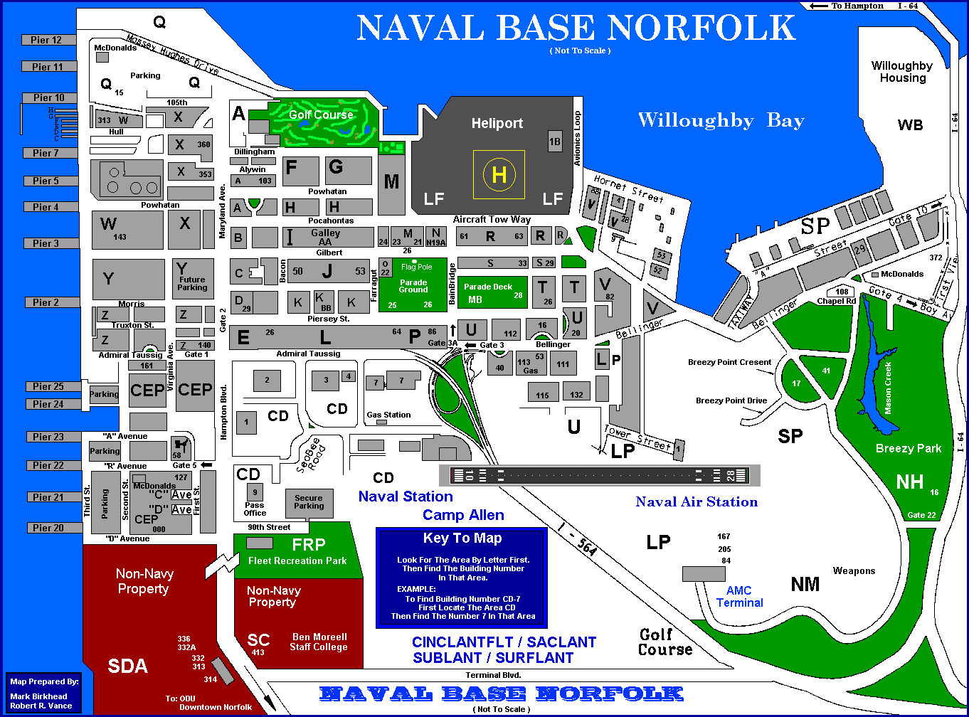
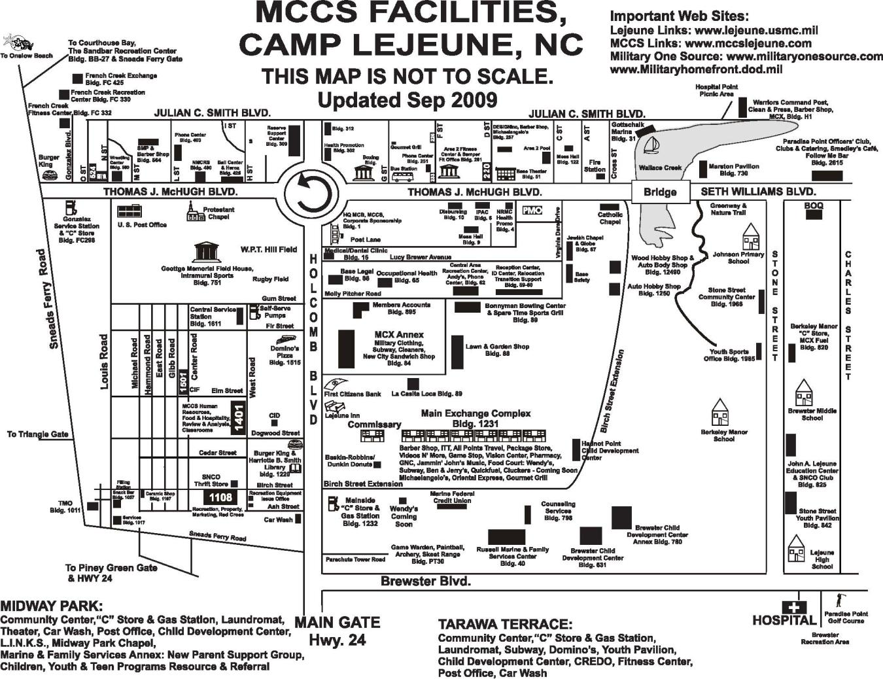

DOWNTOWN NORFOLK

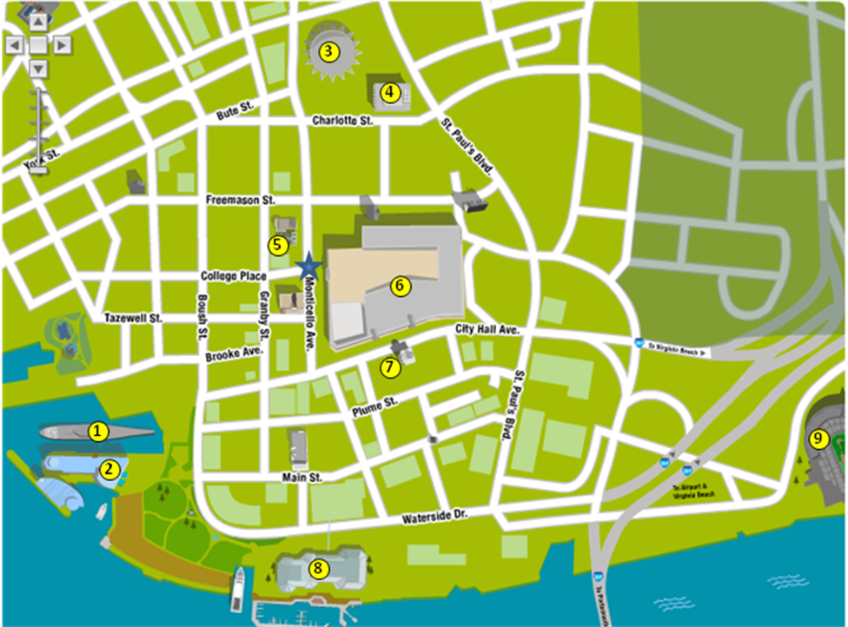

Bus Drop Off / Pick Up Location
- USS Wisconsin – Hampton Roads Naval Museum (www.hrnm.navy.mil)
- Nauticus – The National Maritime Center (www.nauticus.org)
- Norfolk Scope – location of a variety of events (circus, major sporting events, concerts, family shows, etc. (www.sevenvenues.com)
- Chrysler Hall – Performing arts center (www.sevenvenues.com)
- The NORVA – Small music venue with popular bands (www.thenorva.com)
- MacArthur Center – Mall with Movie Theater and arcade (www.shopmacarthur.com)
- MacArthur Memorial – General Douglas MacArthur’s Memorial and Library (www.macarthurmemorial.org)
- Waterside Festival Marketplace – Food court, Outback Steakhouse, Hooters, Jillian's (www.watersidemarketplace.com)
- Harbor Park – Home of the Norfolk Tides - Triple-A Affiliate of the Baltimore Orioles (www.norfolktides.com)

Useful websites: http://www.downtownnorfolk.org/ and http://www.hamptonroadsvisitor.com/

VIRGINIA BEACH

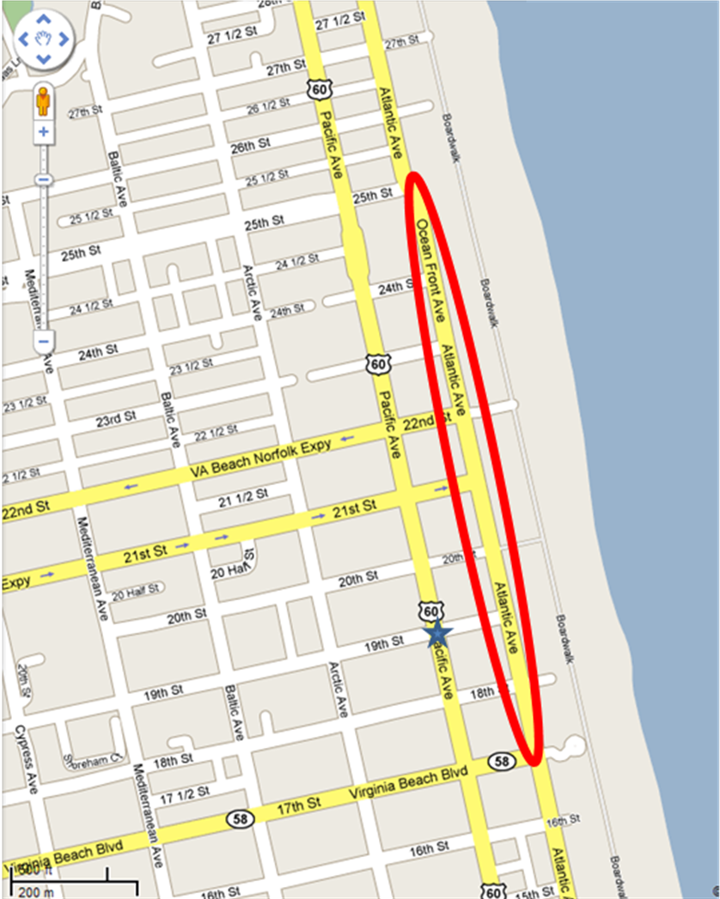

Bus Drop Off / Pick Up Location

Beach Street USA – Tourist/Resort area with a nice beach with a boardwalk and typical beach shops and restaurants

Useful Website: http://www.beachstreetusa.com/ or http://www.vbfun.com/

CORTRAMID EAST 2012 CALENDAR
COMPANY |  | JULY |  |  |  |  |  |  |  |  |  |  |  |  |  |  |  |  |  |  |  |  |  |  |  |  |  |  | AUGUST
COMPANY |  | ARRIVAL |  |  |  | WEEK 1 |  |  |  |  |  |  | WEEK 2 |  |  |  |  |  |  | WEEK 3 |  |  |  |  |  |  | WEEK 4
COMPANY |  | THU | FRI | SAT | SUN | MON | TUE | WED | TH | FRI | SAT | SUN | MON | TUE | WED | TH | FRI | SAT | SUN | MON | TUE | WED | TH | FRI | SAT | SUN | MON | TUE | WED | TH | FRI | SAT
COMPANY |  | 5 | 6 | 7 | 8 | 9 | 10 | 11 | 12 | 13 | 14 | 15 | 16 | 17 | 18 | 19 | 20 | 21 | 22 | 23 | 24 | 25 | 26 | 27 | 28 | 29 | 30 | 31 | 1 | 2 | 3 | 4
A | AM | CKN | MED | PRT | SUBMARINE WEEK |  |  |  |  |  | ENR | LIB | AVSW PHYS |  | AVIATION |  |  | LIB | ENR | MARINE WEEK |  |  |  | ENR | LIB | LIB | SURFACE WEEK |  |  |  |  | DEP
A | PM | CKN | INDOC | ENR
B | AM | CKN | MED | PRT | SUBMARINE WEEK |  |  |  |  |  | ENR | LIB | AVSW PHYS |  | AVIATION |  |  | LIB | ENR | MARINE WEEK |  |  |  | ENR | LIB | LIB | SURFACE WEEK |  |  |  |  | DEP
B | PM | CKN | INDOC | ENR
C | AM | CKN | MED | PRT | LIB | SURFACE WEEK |  |  |  |  | ENR | SUBMARINE WEEK |  |  |  |  |  | ENR | LIB | AVSW PHYS |  | AVIATION |  |  | LIB | ENR | MARINE WEEK |  |  |  | ENR | DEP
C | PM | CKN | INDOC | LIB
D | AM | CKN | MED | PRT | LIB | SURFACE WEEK |  |  |  |  | ENR | SUBMARINE WEEK |  |  |  |  |  | ENR | LIB | AVSW PHYS |  | AVIATION |  |  | LIB | ENR | MARINE WEEK |  |  |  | ENR | DEP
D | PM | CKN | INDOC | LIB
E | AM | CKN | MED | PRT | ENR | MARINE WEEK |  |  |  | ENR | LIB | LIB | SURFACE WEEK |  |  |  |  | ENR | SUBMARINE WEEK |  |  |  |  |  | ENR | LIB | AVSW PHYS |  | AVIATION |  |  | DEP
E | PM | CKN | INDOC | LIB
F | AM | CKN | MED | PRT | ENR | MARINE WEEK |  |  |  | ENR | LIB | LIB | SURFACE WEEK |  |  |  |  | ENR | SUBMARINE WEEK |  |  |  |  |  | ENR | LIB | AVSW PHYS |  | AVIATION |  |  | DEP
F | PM | CKN | INDOC | LIB
G | AM | CKN | MED | PRT | LIB | AVSW PHYS |  | AVIATION |  |  | LIB | ENR | MARINE WEEK |  |  |  | ENR | LIB | LIB | SURFACE WEEK |  |  |  |  | ENR | SUBMARINE WEEK |  |  |  |  |  | DEP JAX
G | PM | CKN | INDOC | LIB
H | AM | CKN | MED | PRT | LIB | AVSW PHYS |  | AVIATION |  |  | LIB | ENR | MARINE WEEK |  |  |  | ENR | LIB | LIB | SURFACE WEEK |  |  |  |  | ENR | SUBMARINE WEEK |  |  |  |  |  | DEP JAX
H | PM | CKN | INDOC | LIB

CKN = Check in
MED = Medical
IN DOC = Indoctrination
PRT = Physical Readiness Test
LIB = Liberty
ENR = En route
AVSW PHYS = Aviation swim and physiology
DEP = Depart

