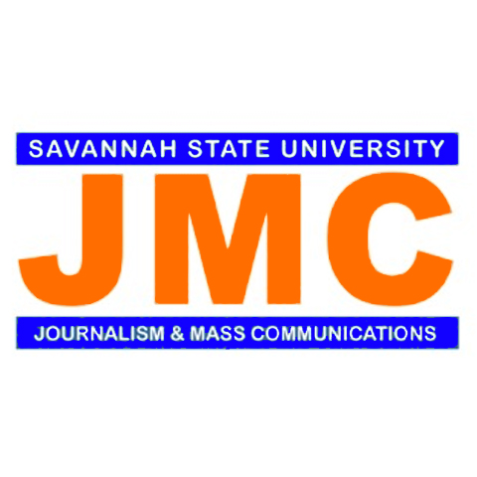
Mentors Application
Department of Journalism and Mass Communications
Alumni Mentoring Program

(Potential mentor: Information you provide on this form will be shared with the department chair, the mentor coordinator and the person who will become your mentee)

Name: Last_______________________ First:___________________ MI/or Maiden:________________

Email Address:__________________________ Current or former hometown:_____________________

Cell phone: ______________________________ Work phone:_________________________________

Your concentration: ______Audio/Video _______P.R. and Advertising ________Online Journalism

Graduate or Other Degrees Earned:_______________________________________________________

Year Graduated from Dept. of Journalism and Mass Communications/SSU: ______________________
Demographics: Age:______ Male:______ Female:______

Attributes that you seek in a mentee (check all that apply):
_______Must have the same area of concentration or career interests
_______Must have a desire to become an entrepreneur
_______First-generation college student
_______Other (please be specific)

Specify the kind of mentoring that you are willing to provide for a mentee. For example, will you critique a resume, discuss internship and career opportunities, provide professional guidance, etc.?
____________________________________________________________________________________
____________________________________________________________________________________
____________________________________________________________________________________

As a mentor, I am willing to commit to (check all that apply):
____one Skype session per month/or per semester
____one or two phone calls per month
____a few e-mails each month

Please return this completed form to holmesn@savannahstate.edu, or print and deliver to
Professor Reginald Franklin, Savannah State University, Box 20634, 3219 College Street, Savannah, GA 31404

